* **[Project: Advanced Online Voting Management System in PHP and MySQL with Source Code](https://www.campcodes.com/projects/php/online-voting-system-in-php/" \l "Project_Advanced_Online_Voting_Management_System_in_PHP_and_MySQL_with_Source_Code" \o "Project: Advanced Online Voting Management System in PHP and MySQL with Source Code )**
  + [**Creating an Online Voting System in PHP: A Comprehensive Guide**](https://www.campcodes.com/projects/php/online-voting-system-in-php/#Creating_an_Online_Voting_System_in_PHP_A_Comprehensive_Guide)
  + [**What is an Online Voting System in PHP?**](https://www.campcodes.com/projects/php/online-voting-system-in-php/#What_is_an_Online_Voting_System_in_PHP)
  + [**Features of  Advanced Online Voting  System in PHP and MySQL**](https://www.campcodes.com/projects/php/online-voting-system-in-php/#Features_of_Advanced_Online_Voting_System_in_PHP_and_MySQL)
  + [**How to Create a Voting System in PHP?**](https://www.campcodes.com/projects/php/online-voting-system-in-php/#How_to_Create_a_Voting_System_in_PHP)
  + [**Which Database is Best for Voting System?**](https://www.campcodes.com/projects/php/online-voting-system-in-php/#Which_Database_is_Best_for_Voting_System)
  + [**What is the Most Common Voting System?**](https://www.campcodes.com/projects/php/online-voting-system-in-php/#What_is_the_Most_Common_Voting_System)
  + [**How to Implement Polling in PHP?**](https://www.campcodes.com/projects/php/online-voting-system-in-php/#How_to_Implement_Polling_in_PHP)
  + [**How to Create an Authentication System in PHP?**](https://www.campcodes.com/projects/php/online-voting-system-in-php/#How_to_Create_an_Authentication_System_in_PHP)
  + [**What is the Main Objective of E-Voting System?**](https://www.campcodes.com/projects/php/online-voting-system-in-php/#What_is_the_Main_Objective_of_E-Voting_System)
  + [**Developing Our Online Voting System**](https://www.campcodes.com/projects/php/online-voting-system-in-php/#Developing_Your_Online_Voting_System)
    - [**Creating the Login and Authentication System**](https://www.campcodes.com/projects/php/online-voting-system-in-php/#Creating_the_Login_and_Authentication_System)
    - [**Election/Contest Creation Module**](https://www.campcodes.com/projects/php/online-voting-system-in-php/#ElectionContest_Creation_Module)
    - [**Voting Module**](https://www.campcodes.com/projects/php/online-voting-system-in-php/#Voting_Module)
    - [**Vote Counting Module**](https://www.campcodes.com/projects/php/online-voting-system-in-php/#Vote_Counting_Module)
    - [**Results Display Module**](https://www.campcodes.com/projects/php/online-voting-system-in-php/#Results_Display_Module)
  + [**Testing, Deployment, and Maintenance**](https://www.campcodes.com/projects/php/online-voting-system-in-php/#Testing_Deployment_and_Maintenance)
    - [**Testing Our System**](https://www.campcodes.com/projects/php/online-voting-system-in-php/#Testing_Your_System)
    - [**Deployment**](https://www.campcodes.com/projects/php/online-voting-system-in-php/#Deployment)
    - [**Maintenance**](https://www.campcodes.com/projects/php/online-voting-system-in-php/#Maintenance)
  + [**Advanced Online Voting System in PHP and MySQL Project**](https://www.campcodes.com/projects/php/online-voting-system-in-php/#Advanced_Online_Voting_System_in_PHP_and_MySQL_Project)
  + [**Screenshots**](https://www.campcodes.com/projects/php/online-voting-system-in-php/#Screenshots)
    - [**Planning and Designing Our Online Voting System**](https://www.campcodes.com/projects/php/online-voting-system-in-php/#Planning_and_Designing_Your_Online_Voting_System)
      * [**Determining the Features and Functionality of Our System**](https://www.campcodes.com/projects/php/online-voting-system-in-php/#Determining_the_Features_and_Functionality_of_Your_System)
      * [**Designing the User Interface of Our System**](https://www.campcodes.com/projects/php/online-voting-system-in-php/#Designing_the_User_Interface_of_Your_System)
    - [**Developing Our Online Voting System**](https://www.campcodes.com/projects/php/online-voting-system-in-php/#Developing_Your_Online_Voting_System-2)
      * [**Creating the Login and Authentication System**](https://www.campcodes.com/projects/php/online-voting-system-in-php/#Creating_the_Login_and_Authentication_System-2)
      * [**Creating the Election/Contest Creation Module**](https://www.campcodes.com/projects/php/online-voting-system-in-php/#Creating_the_ElectionContest_Creation_Module)
      * [**Creating the Vote Counting Module**](https://www.campcodes.com/projects/php/online-voting-system-in-php/#Creating_the_Vote_Counting_Module)
      * [**Creating the Results Display Module**](https://www.campcodes.com/projects/php/online-voting-system-in-php/#Creating_the_Results_Display_Module)
    - [**Testing, Deployment, and Maintenance of Our Online Voting System**](https://www.campcodes.com/projects/php/online-voting-system-in-php/#Testing_Deployment_and_Maintenance_of_Your_Online_Voting_System)
      * [**Testing Our Online Voting System in PHP and MySQL**](https://www.campcodes.com/projects/php/online-voting-system-in-php/#Testing_Your_Online_Voting_System_in_PHP_and_MySQL)
      * [**Deploying Our Online Voting System in PHP MySQL**](https://www.campcodes.com/projects/php/online-voting-system-in-php/#Deploying_Your_Online_Voting_System_in_PHP_MySQL)
  + [**Online Voting System Flowchart**](https://www.campcodes.com/projects/php/online-voting-system-in-php/#Online_Voting_System_Flowchart)
  + [**Online Voting System ER Diagram**](https://www.campcodes.com/projects/php/online-voting-system-in-php/#Online_Voting_System_ER_Diagram)
    - * [**Entities:**](https://www.campcodes.com/projects/php/online-voting-system-in-php/#Entities)
      * [**Relationships:**](https://www.campcodes.com/projects/php/online-voting-system-in-php/#Relationships)
      * [**Maintaining Our Online Voting System in PHP**](https://www.campcodes.com/projects/php/online-voting-system-in-php/#Maintaining_Your_Online_Voting_System_in_PHP)
  + [**How To Run this Online Voting System in PHP and MySQL?**](https://www.campcodes.com/projects/php/online-voting-system-in-php/#How_To_Run_this_Online_Voting_System_in_PHP_and_MySQL)
  + [**Conclusion**](https://www.campcodes.com/projects/php/online-voting-system-in-php/#Conclusion)

**Online Voting Management System in PHP and MySQL with Source Code**

A web-based application that enables users to cast their ballots online is known as an online voting system. This kind of system is frequently utilized because it makes voting procedures easy and efficient in a variety of contexts, including politics, business, and education. This article will walk you through the process of using PHP, one of the most widely used programming languages for web development, to create an online voting system.

**Creating an Online Voting System in PHP: A Comprehensive Guide**

Voters can record a secret ballot and have it electronically calculated using the Advanced Voting Management System in PHP MySQL Free Download election system. Votes are kept on file in case a recount is required.

By greatly lowering the number of workers needed to run a polling station and tabulate results, Voting Management Systems can expedite election results and save election costs. How to preserve votes so they may be recounted if necessary, however, is one of the main issues with electronic voting.

**What is an Online Voting System in PHP?**

A software program that allows users to cast their ballots online is known as an online voting system in PHP. Users can participate at any time and from any location using its effective and convenient voting method. Online voting is popular in many domains, including corporate and business decision-making, political elections, elections at schools and universities, and surveys.

**Features of  Advanced Online Voting  System in PHP and MySQL**

To guarantee a seamless voting experience, our cutting-edge online voting system includes the following features:   
**1.**Vote Preview: Prior to voting being submitted, users can examine their votes.  
2.Many Votes: Encourage the use of several voting methods.   
**3.**A visual depiction of the vote results is provided by the result tally via horizontal barchart.   
**4.**Voting results can be printed in PDF format for use in documentation.   
**5.**The ballot offers a degree of flexibility in the order in which positions are displayed.   
**6.**CRUD Operations for Candidates, Voters, and Positions: Simple data management for candidates, voters, and positions.

**How to Create a Voting System in PHP?**

You must have a solid grasp of PHP's foundational ideas and web development principles in order to design a voting system. The following are the fundamental procedures for developing a voting system:

Clarify the specifications. Determine the goal of our voting system, the kind of voting technique you wish to employ, and the security precautions you must take.   
♣Developing the database schema is the initial stage in building an online voting system. Tables for holding data about voters, candidates, and the voting procedure should be part of the database schema. The following are some essential tables that our database ought to contain:  
♣ People: Voters' personal information, including name, email address, and login credentials, should be kept in this table.   
  
The information on the candidates for office, including their name, party affiliation, and photo, should be kept in this table.

♣ Votes: This table should contain details about the votes that users have cast, such as the candidate and user IDs as well as the time and date of the vote.   
Create the database design. Create the required tables and design the database structure in order to hold user data, voting information, and other pertinent data.  
Create the user interface. Make sure that the ballot and voting options on our voting system have an easy-to-use interface.   
  
♣Creating the online voting system's user interface is the next phase. Voters should be able to readily obtain information about the candidates and cast their ballots via an intuitive and user-friendly user interface. The following are some essential components of our user interface that you should incorporate:   
♣ Every candidate ought to possess a profile page containing details about their qualifications, policies, and positions on significant matters.   
Voting page: Voters should be able to select the candidate of their choice on the voting page.   
Results page: As votes are cast, the page should update in real time to show the current number of votes for each contender.   
Create the backend. Use PHP to create the voting system's back end, which should include the logic for data validation, result computation, and vote counting.   
Evaluate and implement. Install our voting system on a web server and give it a thorough test.

**Which Database is Best for Voting System?**

A voting system's database selection is influenced by a number of variables, including the system's size, user count, and data complexity. However, MySQL, PostgreSQL, and Oracle are a few of the most widely used databases for voting systems.   
An open-source database that is extensively utilized in web applications is called MySQL. It offers good performance, scalability, and ease of use. Strong open-source database PostgreSQL offers sophisticated capabilities like data replication, table partitioning, and transaction support.

**What is the Most Common Voting System?**

First-past-the-post voting, sometimes referred to as plurality voting, is the most widely used voting method in political elections. The candidate who receives the most votes wins the election under this system. On the other hand, a number of alternative voting methods, including proportional representation, ranked choice voting, and approval voting, are employed in various settings**.**

**How to Implement Polling in PHP?**

Creating a back-end script that gathers user poll data, stores it in a database, and computes poll results is required to implement polling in PHP. The following are the fundamental actions needed to set up polling in PHP:   
1. Create the poll form: Create a form that gives the user access to the poll question and available options.   
2. Handle the poll data: Handle the user-submitted poll data and store it in a database.   
3. Compute the poll results: Utilizing the information kept in the database, compute the poll results and present them to the user.

**How to Create an Authentication System in PHP?**

You must write a back-end script that verifies user credentials and grants access to the voting system in order to establish an authentication system in PHP. The fundamental procedures for setting up an authentication system in PHP are as follows:   
1. Create the database. Create the required tables and design the database structure in order to store user data, login credentials, and other pertinent data.  
2. Create the form for login. Create an intuitive login form that asks the user to submit their login information.   
  
3. Verify the login information. Verify that the user's login credentials match the data kept in the database.   
Establish user sessions. Establish user sessions to give users access to the voting system and to preserve their login status.

**What is the Main Objective of E-Voting System?**

The primary goal of an electronic voting system is to give voters a quick and easy means to cast their ballots, anytime, anyplace. By decreasing fraud, maximizing errors, and boosting transparency, electronic voting systems also seek to enhance the voting process's integrity and accuracy. E-voting technologies can also cut down on the expense and time associated with conventional voting procedures.

**Developing our Online Voting System**

**Creating the Login and Authentication System**

To secure access to the voting platform, start by putting in place a strong login and authentication mechanism. Verify user credentials, control user sessions, and employ encryption to improve security.

**Election/Contest Creation Module**

Design a module to create and manage elections or contests. Allow administrators to define election parameters such as title, description, candidates, and voting duration.

**Voting Module**

Develop the core voting functionality, enabling users to cast their votes online. Present voters with clear options, validate votes, and ensure data integrity throughout the process.

**Vote Counting Module**

Implement a module to tally votes and calculate results accurately. Apply appropriate algorithms to handle different voting methods and generate comprehensive reports.

**Results Display Module**

Create a module to showcase election results to users in an understandable format. Utilize tables, graphs, or charts to visualize data and provide insights into voting outcomes.

**Testing, Deployment, and Maintenance**

**Testing Our System**

Thoroughly test our voting system to identify and rectify any bugs or vulnerabilities. Conduct usability testing with real users to gather feedback for improvement.

**Deployment**

Deploy our system on a reliable web hosting service, ensuring compatibility with PHP, MySQL, and other required technologies. Secure data transmission with SSL encryption for user privacy.

**Maintenance**

Regularly update our system to incorporate new features and address security concerns. Monitor system performance, fix bugs promptly, and provide ongoing support to users.

**Advanced Online Voting System in PHP and MySQL Project**

* **Name of Project:**    **Advanced Online Voting System in PHP** **Project**
* **Language**:                 PHP
* **Databases used**:     MySQL
* **Design used**:            HTML JavaScript, Ajax, JQuery, Bootstrap
* **Browser used:**          IE8, Microsoft Edge, Brave
* **Software used:**         WAMP/ XAMPP/ LAMP/MAMP

**Screenshots**

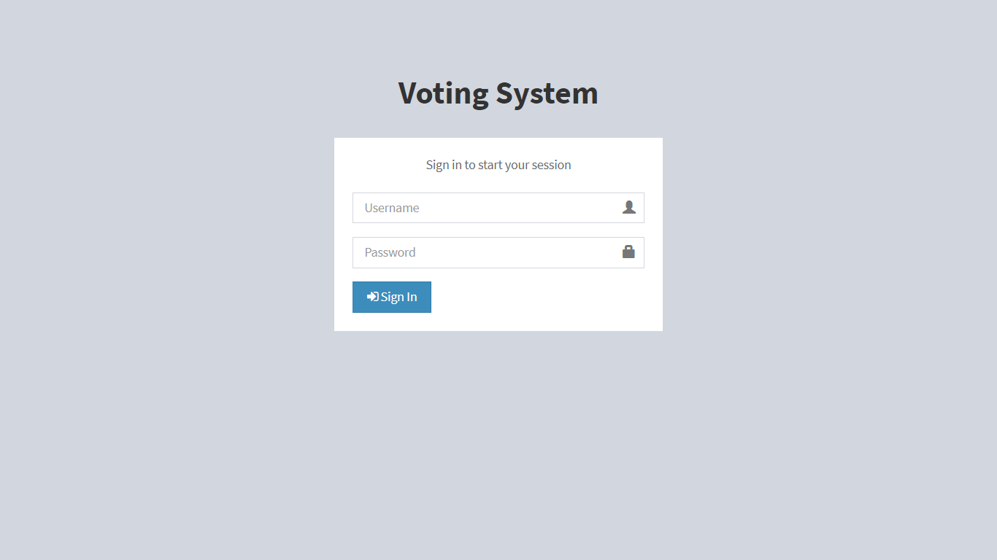

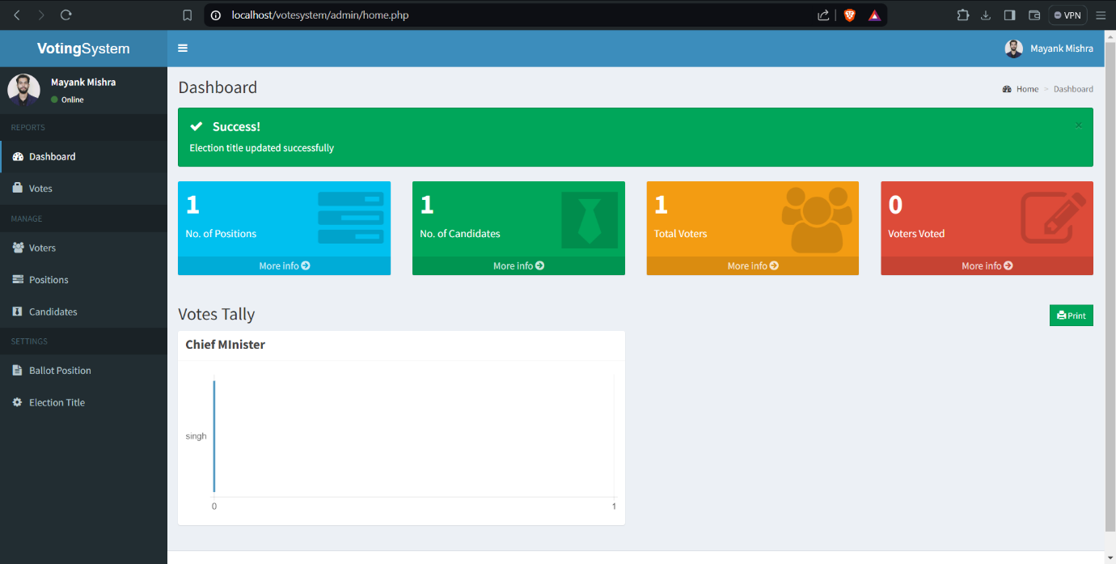

**Planning and Designing our Online Voting System**

In this section, we’ll discuss the planning and designing stage of our online voting system. This includes determining the features and functionality of our system and designing its user interface.

**Determining the Features and Functionality of Our System**

Before you start coding our online voting system, you must first plan and conceptualize its features and functionality. Below are some questions to help you get started:

* What types of elections or contests can be created?
* What are the specifications and requirements of each election or contest?
* How many candidates or entries are allowed?
* What types of voting systems are supported?
* How can voters cast and modify their votes online?
* What types of reports and analytics are needed?
* How will the system handle errors, invalid votes, and fraud attempts?

Answering these questions can help you create a clear and concise plan for our online voting system.

**Designing the User Interface of Our System**

After you determine the features and functionality of our online voting system, the next step is to design its user interface. The user interface is the visual and functional representation of our system, and it’s crucial to make it user-friendly and accessible.

Here are some tips to consider when designing our system’s user interface:

1. Keep it simple and easy to navigate
2. Use clear and concise labels and instructions
3. Make it responsive and accessible through different devices and platforms
4. Use contrasting colors and visual hierarchies to highlight important elements
5. Test it with real users to get feedback and improve its usability

**Developing Our Online Voting System**

In this section, we’ll discuss the core functionality of our online voting system. This includes creating the login and authentication system, election/contest creation module, voting module, vote counting module, and results display module.

**Creating the Login and Authentication System**

The login and authentication system is responsible for verifying the identity of the user and granting them access to specific features or resources. Here are the steps to create one in PHP:

1. Create a login form that can accept the username and password of the user.
2. Validate the user’s credentials by checking them against the database records.
3. Store the user’s login session and permission levels in a session variable.
4. Implement a logout feature that can terminate the user’s login session.
5. Secure the login and authentication system by using encryption, password hashing, and other security measures.

**Creating the Election/Contest Creation Module**

The election/contest creation module is responsible for creating and managing elections or contests. Here are the steps to create one in PHP:

1. Create a form that can collect the necessary information for creating an election/contest, such as the title, description, start and end dates, and candidates or entries.
2. Validate the information and store it in the database.
3. Display the list of existing elections/contests and allow the user to edit or delete them.
4. H4: Creating the Voting Module
5. The voting module is responsible for allowing voters to cast and modify their votes online. Here are the steps to create one in PHP:
6. Create a form that can display the election/contest details and the candidates or entries.
7. Allow the user to select one or more candidates or entries and submit their vote.
8. Validate the vote and store it in the database.
9. Allow the user to modify their vote before the deadline.

**Creating the Vote Counting Module**

The vote counting module is responsible for tallying the votes and computing the results. Here are the steps to create one in PHP:

1. Retrieve the votes from the database and organize them according to the voting system used.
2. Apply the vote counting algorithm and compute the results.
3. Store the results in the database and display them to the users.

**Creating the Results Display Module**

The results display module is responsible for showing the election/contest results to the users. Here are the steps to create one in PHP:

1. Retrieve the results from the database and display them in a table or graph.
2. Allow the user to filter and sort the results according to different criteria.
3. Provide a summary and analysis of the results using charts or other visual aids.

**Testing, Deployment, and Maintenance of Our Online Voting System**

In this section, we’ll discuss the testing, deployment, and maintenance of our online voting system. This includes testing it for bugs, errors, and vulnerabilities, deploying it on the web, and maintaining it for updates and improvements.

**Testing Our Online Voting System in PHP and MySQL**

Testing our online voting system is crucial to ensure its security, functionality, and usability. Here are some tips to consider when testing our system:

* Use automated testing tools to check for bugs and vulnerabilities.
* Test our system on different devices, platforms, and browsers.
* Involve real users to test the system’s usability and user experience.
* Assess the system’s security using penetration testing and vulnerability scanning.

**Deploying our Online Voting System in PHP MySQL**

Deploying our online voting system on the web requires the following steps:

1. Choose a reliable web hosting service that can support PHP, MySQL, and other web technologies.
2. Register a domain name that suits our online voting system and is easy to remember.
3. Obtain an SSL certificate to secure our system’s data transmission and communication.
4. Configure our server’s settings and database to ensure optimal performance and security.

**Online Voting System Flowchart**

This flowchart provides a detailed depiction of the entire process flow within the online voting system, starting from user authentication to the creation of elections, casting votes, accessing results, and finally logging out. Each step is clearly defined, indicating the flow of actions and decisions within the system. **Online Voting System ER Diagram**

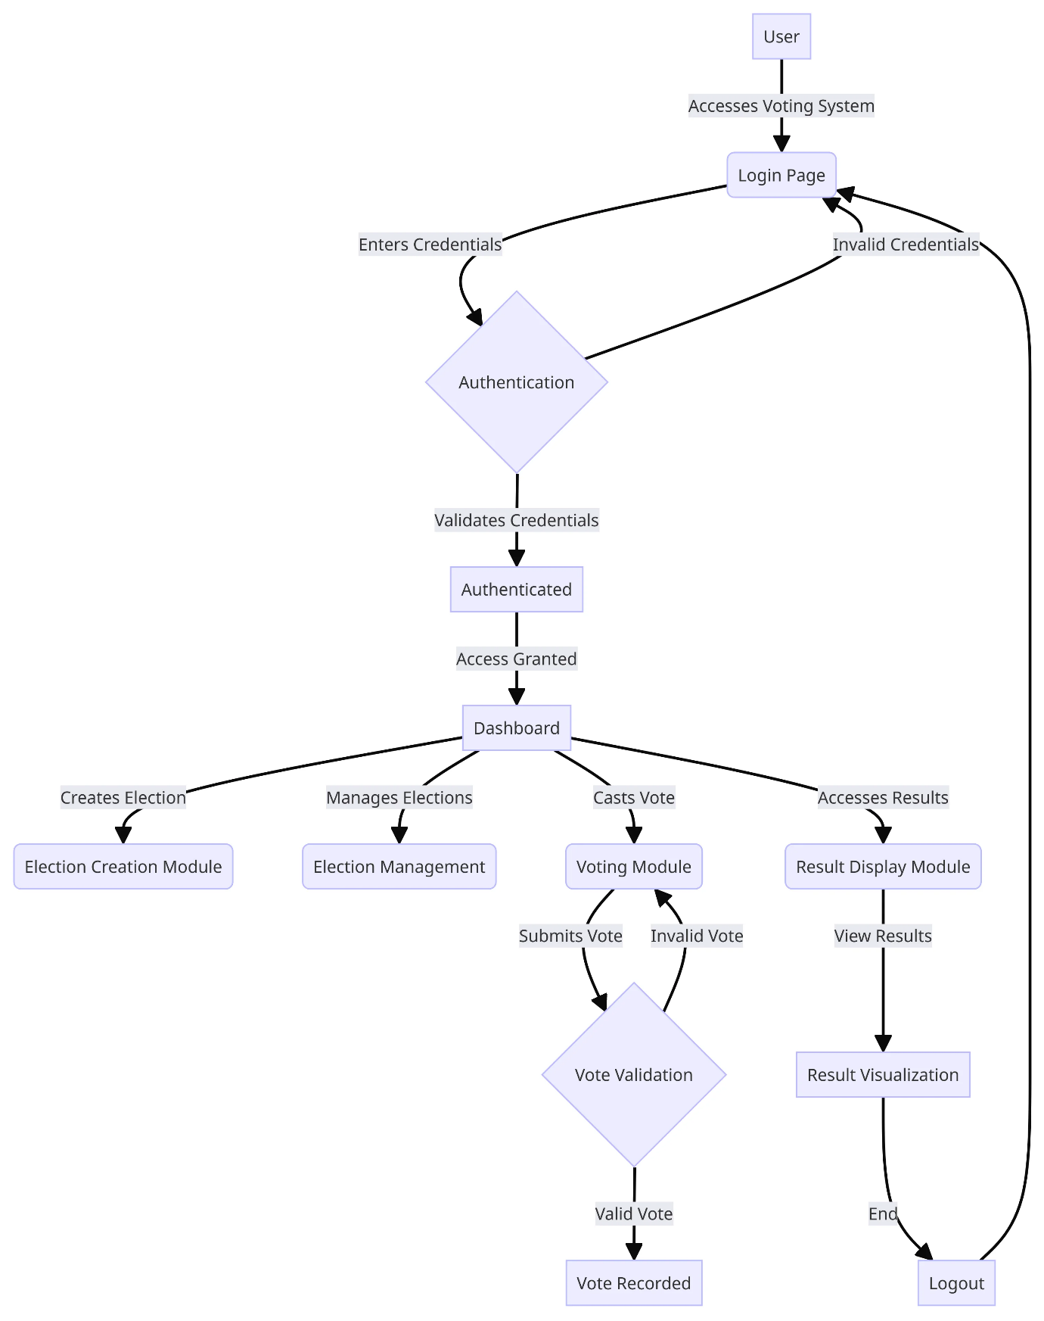

**Online Voting System ER Diagram**

**Entities:**

1. **User**:
   * Attributes:
     + **id**: Primary Key (PK) representing the unique identifier for each user.
     + **username**: VARCHAR field storing the username of the user.
     + **password**: VARCHAR field storing the password of the user.
     + **role**: VARCHAR field representing the role of the user (e.g., ‘admin’ or ‘voter’).
2. **Election**:
   * Attributes:
     + **id**: Primary Key (PK) representing the unique identifier for each election.
     + **title**: VARCHAR field storing the title of the election.
     + **description**: TEXT field storing the description of the election.
     + **start\_date**: DATETIME field indicating the start date and time of the election.
     + **end\_date**: DATETIME field indicating the end date and time of the election.
3. **Candidate**:
   * Attributes:
     + **id**: Primary Key (PK) representing the unique identifier for each candidate.
     + **name**: VARCHAR field storing the name of the candidate.
     + **party\_affiliation**: VARCHAR field storing the party affiliation of the candidate.
     + **photo\_url**: VARCHAR field storing the URL of the candidate’s photo.
     + **election\_id**: Foreign Key (FK) referencing the election to which the candidate belongs.
4. **Vote**:
   * Attributes:
     + **id**: Primary Key (PK) representing the unique identifier for each vote.
     + **voter\_id**: Foreign Key (FK) referencing the user who cast the vote.
     + **candidate\_id**: Foreign Key (FK) referencing the candidate for whom the vote is cast.
     + **date\_time**: DATETIME field indicating the date and time when the vote was cast.

**Relationships:**

1. **User-Vote**:
   * One-to-Many relationship indicating that a user can submit multiple votes.
   * Relationship Label: “Submits”
2. **User-Election**:
   * One-to-Many relationship indicating that a user can manage multiple elections.
   * Relationship Label: “Manages”
3. **Election-Candidate**:
   * One-to-Many relationship indicating that an election can have multiple candidates competing.
   * Relationship Label: “Competes In”
4. **Vote-User**:
   * One-to-Many relationship indicating that a vote is cast by a single user.
   * Relationship Label: “Cast By”
5. **Vote-Candidate**:
   * One-to-Many relationship indicating that a vote is cast for a single candidate.
   * Relationship Label: “Cast For”

**ONLINE VOTING SYSTEM ER DIAGRAM**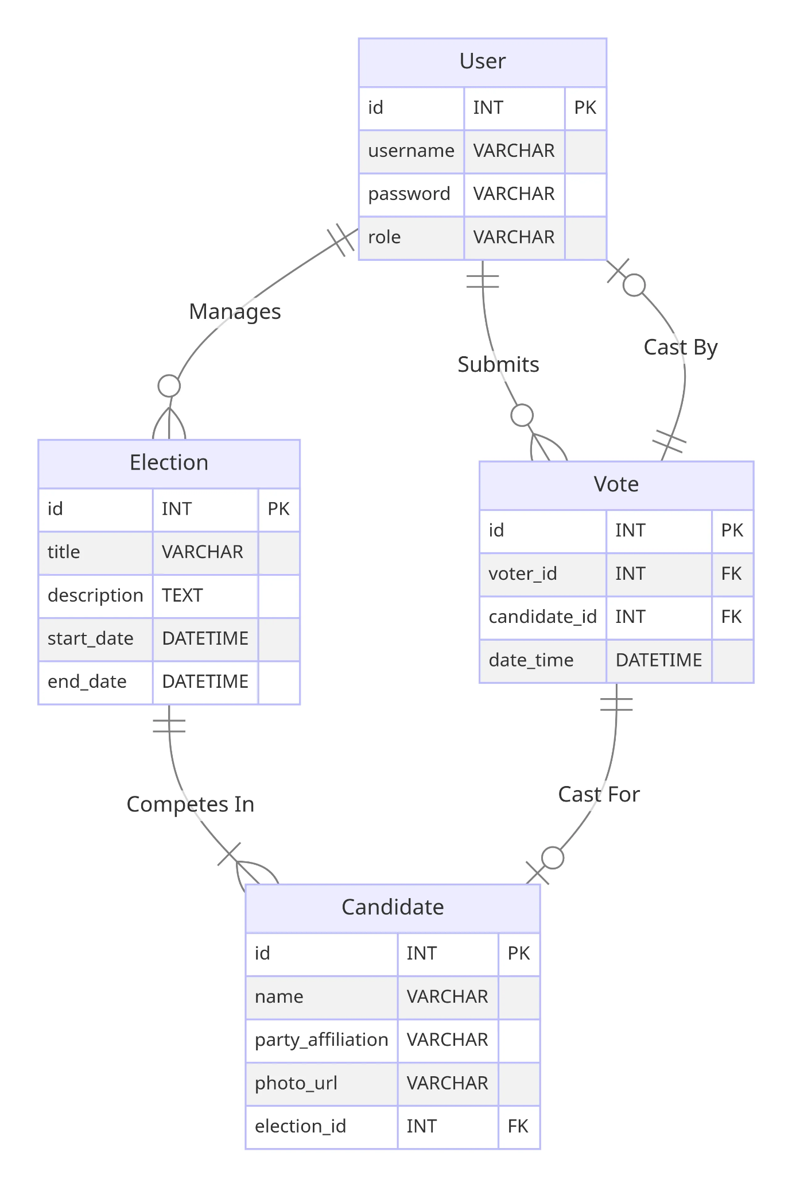

**Maintaining our Online Voting System in PHP**

Maintaining our online voting system involves keeping it up-to-date, fixing bugs and errors, and improving its features and functionality. Here are some tips to consider:

* Regularly update our system to the latest version of PHP, MySQL, and other web technologies.
* Fix bugs and errors promptly to ensure optimal performance and security.
* Implement user feedback and suggestions to improve our system’s usability and user experience.
* Conduct security audits and risk assessments to identify potential threats and vulnerabilities.

**How To Run this Online Voting System in PHP and MySQL?**

Above all, to run this project you must have installed a virtual server i.e [XAMPP](https://www.apachefriends.org/download_success.html) on our PC. **Advanced Online Voting System** in PHP and MySQL with source code is free to download, **Use for educational purposes only!**

*Follow the following steps after Starting Apache and MySQL in XAMPP:*

***1st Step****:* Firstly, Extract the file  
***2nd Step:*** After that, Copy the main project folder  
***3rd Step:*** So, you need to Paste in xampp/htdocs/

***Further, Now Connecting Database***

***4th Step:*** So, for now, Open a browser and go to URL “http://localhost/phpmyadmin/”  
***5th Step:*** After that, Click on the databases tab  
***6th Step:*** So, Create a database naming “votingsystem” and then click on the import tab  
***7th Step:*** Certainly, Click on browse file and select “[votingsystem.](https://www.campcodes.com/php/5163/online-shopping-system-using-php-mysql/)**[sql](https://www.campcodes.com/php/5163/online-shopping-system-using-php-mysql/)**” file which is inside the “db” folder  
***8th Step:*** Meanwhile, click on Go button.

***After Creating Database***,

***9th Step:*** Moreover, Open a browser and go to URL “http://localhost/votingsystem”

**Conclusion**

Creating an online voting system in PHP and MySQL offers numerous benefits for organizations and institutions seeking to streamline their election processes. By following this comprehensive guide, you can develop a secure, accessible, and efficient voting platform tailored to our specific requirements. Empower our stakeholders with the ability to participate in elections conveniently and securely—start building our online voting system today